2. FINGERPRINT RECOGNITION
2.1 Overview
This chapter presents the main characteristics of fingerprint recognition. The architecture of fingerprint recognition system and the function of its main components are described. Fingerprint sensing, fingerprint representation and feature extraction, fingerprint matching, fingerprint classification and indexing, synthetic fingerprints, applications of fingerprint recognition systems are given.
2.2 Fingerprints as a Biometric
A smoothly flowing pattern formed by alternating crests (ridges) and troughs (valleys) on the palmar aspect of hand is called a palmprint. Formation of a palmprint depends on the initial conditions of the embryonic mesoderm from which they develop. The pattern on pulp of each terminal phalanx is considered as an individual pattern and is commonly referred to as a fingerprint. A fingerprint is believed to be unique to each person. Fingerprints of even identical twins are different.

Fingerprints are one of the most mature biometric technologies and are considered legitimate proofs of evidence in courts of law all over the world. Fingerprints are, therefore, used in forensic divisions worldwide for criminal investigations. More recently, an increasing number of civilian and commercial applications are either using or actively considering using fingerprint-based identification because of a better understanding of fingerprints as well as demonstrated matching performance than any other existing biometric technology. [5]

Humans have used fingerprints for personal identification for a very long time. Modern fingerprint matching techniques were initiated in the late 16th century. Henry Fauld, in 1880, first scientifically suggested the individuality and uniqueness of fingerprints. At the same time, Herschel asserted that he had practiced fingerprint identification for about 20 years. This discovery established the foundation of modern fingerprint identification. In the late 19th century, Sir Francis Galton conducted an extensive study of fingerprints. He introduced the minutiae features for single fingerprint classification in 1888. The discovery of uniqueness of fingerprints caused an immediate decline in the prevalent use of anthropometric methods of identification and led to the adoption of fingerprints as a more efficient method of identification. An important advance in fingerprint identification was made in 1899 by Edward Henry, who (actually his two assistants from India) established the famous “Henry system” of fingerprint classification: an elaborate method of indexing fingerprints very much tuned to facilitating the human experts performing (manual) fingerprint identification. In the early 20th century, fingerprint identification was formally accepted as a valid personal identification method by law enforcement agencies and became a standard procedure in forensics. Fingerprint identification agencies were setup worldwide and criminal fingerprint databases were established [2]. With the advent of livescan fingerprinting and availability of cheap fingerprint sensors, fingerprints are increasingly used in government and commercial applications for positive person identification.
Figure 2.1: Fingerprints and a fingerprint classification schema involving six categories: (a) arch, (b) tented arch, (c) right loop, (d) left loop, (e) whorl, and (f) twin loop. Critical points in a fingerprint, called core and delta, are marked as squares and triangles. [6]

2.3 Architecture of Fingerprint identification System
The common architecture of a fingerprint-based automatic identity authentication system is shown in Figure 2.2. It consists of four components: (I) user interface, (II) system database, (III) enrollment module, and (VI) authentication module. The user interface provides mechanisms for a user to indicate his/her identity and input his/her fingerprints into the system. The system database consists of a collection of records, each of which corresponds to an authorized person that has access to the system. Each record contains the following fields which are used for authentication purpose: (I) user name of the person, (II) minutiae templates of the person’s fingerprint, and (III) other information (e.g., specific user privileges). [6]

The task of enrolment module is to enrol persons and their fingerprints into the system
Database. When the fingerprint images and the user name of a person to be enrolled are fed to the enrolment module, a minutiae extraction algorithm is first applied to the fingerprint images and the minutiae patterns are extracted. A quality checking algorithm is used to ensure that the records in the system database only consist of fingerprints of good quality, in which a significant number (default value is 25) of genuine minutiae may be detected. If a fingerprint image is of poor quality, it is enhanced to improve the clarity of ridge/valley structures and mask out all the regions that cannot be reliably recovered. The enhanced fingerprint image is fed to the minutiae extractor again.

The task of authentication module is to authenticate the identity of the person who intends to access the system. The person to be authenticated indicates his/her identity and places his/her finger on the fingerprint scanner; a digital image of his/her fingerprint is captured; minutiae pattern is extracted from the captured fingerprint image and fed to a matching algorithm which matches it against the person’s minutiae templates stored in the system database to establish the identity.
Figure 2.2: Architecture of an automatic identity authentication system.

2.4 Fingerprint Sensing
There are two primary methods of capturing a fingerprint image: inked (off-line) and live scan (ink-less) (see Figure 2.3). An inked fingerprint image is typically acquired in the following way: a trained professional obtains an impression of an inked finger on a paper and the impression is then scanned using a flat bed document scanner. The live scan fingerprint is a collective term for a fingerprint image directly obtained from the finger without the intermediate step of getting an impression on a paper. Acquisition of inked fingerprints is cumbersome; in the context of an identity authentication system, it is both infeasible and socially unacceptable. The most popular technology to obtain a live-scan fingerprint image is based on optical frustrated total internal reflection (FTIR) concept. When a finger is placed on one side of a glass platen (prism), ridges of the finger are in contact with the platen, while the valleys of the finger are not in contact with the platen. The rest of the imaging system essentially consists of an assembly of a bank of light-emitting diodes LED and a high quality camera placed on the other side of the glass platen. The laser light source illuminates the glass at a certain angle and the camera is placed such that it can capture the laser light reflected from the glass. The light incidenting on the platen at the glass surface touched by the ridges is randomly scattered while the light incidenting at the glass surface corresponding to valleys suffers total internal reflection. Consequently, a portion of the image formed on the imaging plane of a high quality camera corresponding to ridge is dark and that corresponding to valleys is bright. More recently, capacitance-based solid state live-scan fingerprint sensors are gaining popularity since they are very small in size and hold promise of becoming inexpensive in the near future. A capacitance-based fingerprint sensor essentially consists of an array of electrodes. The fingerprint skin acts as the other electrode, thereby, forming a miniature capacitor. The capacitance due to the ridges is higher than those formed by valleys. This differential capacitance is the basis of operation of a capacitance-based solid state sensor. [7]
Figure 2..3: Fingerprint sensing: (a) An inked fingerprint image could be captured from the inked impression of a finger; (b) a livescan fingerprint is directly imaged from a live finger based on optical total internal reflection principle: the light scatters where finger (e.g., ridges) touch the glass prism and light reflects where finger (e.g., valleys) does not touch the glass prism. (c) rolled fingerprints are images depicting nail-to-nail area of a finger (d) fingerprints captured using solid state sensors show a smaller area of finger than a typical fingerprint dab captured using optical scanners. (e) a latent fingerprint refers to partial print typically lifted from a scene of crime.[3]

2.5 Fingerprint Representation and Feature Extraction
The representation issue constitutes the essence of fingerprint recognition system design and has far-reaching implications for the design of the rest of the system. The pixel intensity values in the fingerprint image are typically not invariant over the time of capture and there is a need to determine salient features of the input fingerprint image that can discriminate between identities as well as remain invariant for a given individual. Thus the problem of representation is to determine a measurement (feature) space in which the fingerprint images belonging to the same finger form a compact cluster and those belonging to different fingers occupy different portions of the space. [6]
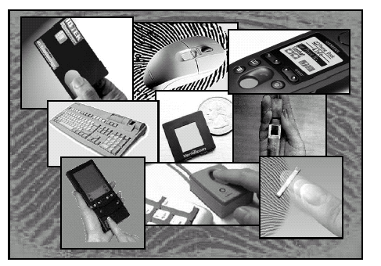
Figure 2.4. Fingerprint sensors can be embedded in a variety of devices for user recognition purposes. [4]

A good fingerprint representation should have the following two properties: saliency and suitability. Saliency means that a representation should contain distinctive information about the fingerprint. Suitability means that the representation can be easily extracted, stored in a compact fashion, and be useful for matching. Saliency and suitability properties are not generally correlated. A salient representation is not necessarily a suitable representation. In addition, in some biometric applications, storage space is at a premium. For example, in a smartcard application, typically about
2 Kbytes of storage are available. In such situations, the representation also needs to be rare.
Image-based representations, constituted by raw pixel intensity information, are prevalent among the recognition systems using optical matching and correlation-based matching. However, the utility of the systems using such representation schemes may be limited due to factors such as brightness variations, image quality variations, scars, and large global distortions present in the fingerprint image. Furthermore, an image-based representation requires a considerable amount of storage. On the other hand, an image-based representation preserves the maximum amount of information, makes fewer assumptions about the application domain, and therefore has the potential to be robust to wider varieties of fingerprint images. For instance, it is extremely difficult to extract robust features from a (degenerate) finger devoid of any ridge structure.

The fingerprint pattern, when analyzed at different scales, exhibits different types of features:
• At the global level, the ridge line flow delineates a pattern similar to one of those shown in Figure 2.5. Singular points, called loop and delta (denoted as squares and triangles, respectively in Figure 2.5), are a sort of control points around which the ridge lines are “wrapped” (Levi and Sirovich, 1972). Singular points and coarse ridge line shape are very important for fingerprint classification and indexing, but their distinctiveness is not sufficient for accurate matching. External fingerprint shape, orientation image, and frequency image also belong to the set of features that can be detected at the global level.

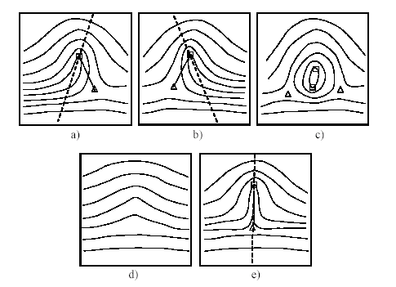
Figure 2.5. Fingerprint patterns as they appear at a coarse level: a) left loop; b) right loop; c) whorl; d) arch; and e) tented arch; squares denote loop-type singular points, and triangles deltatype singular points.
• At the local level, a total of 150 different local ridge characteristics, called minute details, have been identified (Moenssens, 1971). These local ridge characteristics are not evenly distributed. Most of them depend heavily on the impression conditions and quality of fingerprints and are rarely observed in fingerprints. The two most prominent ridge characteristics, called minutiae (see Figure 3.6), are: ridge termination and ridge bifurcation. A ridge ending is defined as the ridge point where a ridge ends abruptly. A ridge bifurcation is defined as the ridge point where a ridge forks or diverges into branch ridges. Minutiae in fingerprints are generally stable and robust to fingerprint impression conditions.

• At the very-fine level, intra-ridge details can be detected. These are essentially the finger sweat pores (see Figure 2.6) whose position and shape are considered highly distinctive. However, extracting pores is feasible only in high-resolution fingerprint images (e.g., 1000 dpi) of good quality and therefore this kind of representation is not practical for most applications.
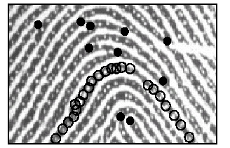
Figure 2.6. Minutiae (black-filled circles) in a portion of fingerprint image; sweat pores (empty circles) on a single ridge line. [8]

2.6 Fingerprint Matching
Reliably matching fingerprint images is an extremely difficult problem, mainly due to the large variability in different impressions of the same finger (i.e., large intra-class variations). The main factors responsible for the intra-class variations are: displacement, rotation, partial overlap, non-linear distortion, variable pressure, changing skin condition, noise, and feature extraction errors. Therefore, fingerprints from the same finger may sometimes look quite different whereas fingerprints from different fingers may appear quite similar (see Figure 2.7).
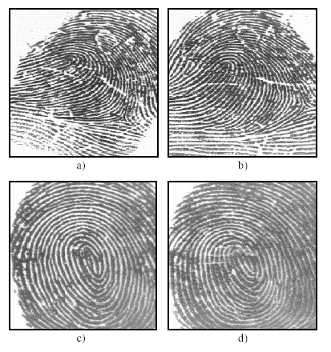
Figure 2.7. Difficulty in fingerprint matching. Fingerprint images in a) and b) look different to an untrained eye but they are impressions of the same finger. Fingerprint images in c) and d) look similar to an untrained eye but they are from different fingers. [3]

In order to claim that two fingerprints are from the same finger, Human fingerprint examiners evaluate several factors: i) global pattern configuration agreement, which means that two fingerprints must be of the same type, ii) qualitative concordance, which requires that the corresponding minute details must be identical, iii) quantitative factor, which specifies that at least a certain number (a minimum of 12 according to the forensic guidelines in the United States) of corresponding minute details must be found, and iv) corresponding minute details, which must be identically inter-related. In practice, complex protocols have been defined for fingerprint matching and a detailed flowchart is available to guide fingerprint examiners in manually performing fingerprint matching. [8]

Automatic fingerprint matching does not necessarily follow the same guidelines. In fact, although automatic minutiae-based fingerprint matching is inspired by the manual procedure, a large number of approaches have been designed over the last 40 years, and many of them have been explicitly designed to be implemented on a computer. A (three-class) categorization of fingerprint matching approaches is:
• Correlation-based matching: two fingerprint images are superimposed and the correlation (at the intensity level) between corresponding pixels is computed for different alignments (e.g., various displacements and rotations);
• Minutiae-based matching: minutiae are extracted from the two fingerprints and stored as sets of points in the two-dimensional plane. A minutia matching essentially consists of finding the alignment between the template and the input a minutia sets that results in the maximum number of minutiae pairings;
• Ridge feature-based matching: minutiae extraction is difficult in very low-quality fingerprint images, whereas other features of the fingerprint ridge pattern (e.g., local orientation and frequency, ridge shape, texture information) may be extracted more reliably than minutiae, even though their distinctiveness is generally lower. The approaches belonging to this family compare fingerprints in term of features extracted from the ridge pattern. [8]

Given a complex operating environment, it is critical to identify a set of valid assumptions upon which the fingerprint matcher design could be based. Often there is a choice between whether it is more effective to exert more constraints by incorporating better engineering design or to build a more sophisticated similarity function for the given representation. For instance, in a fingerprint matcher, one could constrain the elastic distortion altogether and design the matcher based on a rigid transformation assumption or allow arbitrary distortions and accommodate the variations in the input images using a clever matcher. In light of the operational environments mentioned above, the design of the matching algorithm needs to establish and characterize a realistic model of the variations among the representations of mated pairs.

2.7 Fingerprint Classification and Indexing
Large volumes of fingerprints are collected and stored every day in a wide range of applications, including forensics, access control, and driver’s license registration. Automatic identification based on fingerprints requires the input fingerprint to be matched with a large number of fingerprints stored in a database (e.g., the FBI database contains more than 200 million fingerprint cards). To reduce the search time and computational complexity, it is desirable to classify these fingerprints in an accurate and consistent manner such that the input fingerprint needs to be matched only with a subset of the fingerprints in the database. Fingerprint classification is a technique used to assign a fingerprint to one of the several pre-specified types already established in the literature (see Figure 2.8). Fingerprint classification can be viewed as a coarse-level matching of the fingerprints. An input fingerprint is first matched to one of the pre-specified types and then it is compared to a subset of the database corresponding to that fingerprint type. For example, if the fingerprint database is binned into five classes, and a fingerprint classifier outputs two classes (primary and secondary) with extremely high accuracy, then the identification system will only need to search two of the five bins, thus decreasing (in principle) the search space 2.5-fold. Unfortunately, only a limited number of major fingerprint categories have been identified (e.g., five), the distribution of fingerprints into these categories is not uniform, and there are many “ambiguous” fingerprints (see Figure 2.8), whose exclusive membership cannot be reliably stated even by human experts. In fact, the definition of each fingerprint category is both complex and vague. A human inspector needs a long period of experience to reach a satisfactory level of performance in fingerprint classification. About 17% of the 4000 images in the (National Institute of Standards and Technology-USA) NIST Special Database 4 (Watson and Wilson, 1992a) have two different ground truth labels. This means that even human experts could not agree on the true class of the fingerprint for about 17% of the fingerprint images in this database. Therefore, in practice, fingerprint classification is not immune to errors and does not offer much selectivity for fingerprint searching in large databases. [9]

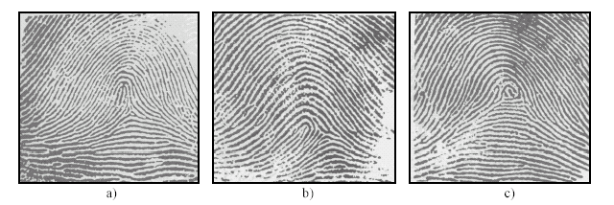
Figure 2.8. Examples of fingerprints that are difficult to classify; a) tented arch; b) a loop; c) a whorl; it seems that all the fingerprints shown here should be in the loop category. [4]

To overcome this problem, some authors have proposed methods based on “continuous classification” or on other indexing techniques. In continuous classification, fingerprints are not partitioned into non-overlapping classes, but each fingerprint is characterized with a numerical vector summarizing its main features. The continuous features obtained are used for indexing fingerprints through spatial data structures and for retrieving fingerprints by means of spatial queries.

2.8 Synthetic Fingerprints
Performance evaluation of fingerprint recognition systems is very data dependent. Therefore the acquisition conditions, database size, and confidence intervals must be specified when reporting the results. Typically, to obtain tight confidence intervals at very low error rates, large databases of representative fingerprint images are required. Moreover, once a fingerprint database has been used for testing and optimizing a system, successive testing cycles require new databases previously unseen by the system.

Unfortunately, collection of large fingerprint databases is not only expensive in terms of time and money, it is also problematic because of the repetitive monotony of the work (which often leads to collection errors) and of privacy legislation protecting the use of personal data. In several contexts, a synthetic generation of realistic fingerprint images will solve these problems. The most desirable property of such a synthetic fingerprint generator is that it correctly models the various inter-class and intra-class variations in fingerprint images observed in nature. In particular, it should be able to generate realistic “impressions” of the same “virtual finger,” by simulating:
• Different touching areas;
• Non-linear distortions produced by non-orthogonal pressure of the finger against the sensor;
• Variations in the ridge line thickness given by pressure intensity or by skin dampness;
• Small cuts on the fingertip and other kinds of noise.
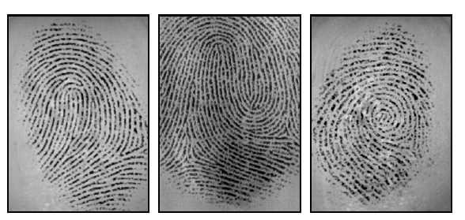
Figure 2.9. Synthetic fingerprint images generated with the software tool SFINGE [9]

2.9 Applications of Fingerprint Recognition Systems

Fingerprint recognition is a rapidly evolving technology that has been widely used in forensics such as criminal recognition and prison security, and has a very strong potential to be widely adopted in a broad range of civilian applications (see Table 3.1 and Figure 2.10).

Forensic | Government | Commercial
Corpse Identification,  Criminal Investigation,  Parenthood Determination,  Missing Children, etc. | National ID card,  Correctional Facility,  Driver’s License,  Social Security,  Welfare Disbursement,  Border Control,  Passport Control, etc. | Computer Network Logon,  Electronic Data Security,  E-Commerce,  Internet Access,  ATM, Credit Card,  Physical Access Control,  Cellular Phones,  Personal Digital Assistant,  Medical Records Management,  Distance Learning, etc.

Table 2.1. Most of the fingerprint recognition applications are divided here into three categories. Traditionally, forensic applications have used manual biometrics, government applications have used token-based systems, and commercial applications have used knowledge-based systems. Fingerprint recognition systems are now being increasingly used for all these sectors. Note that “double dipping” welfare recipients in the United States alone annually claim over one billion dollars in welfare benefits. [3]

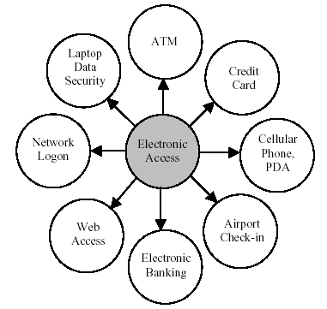
Figure 2.10. Various electronic access applications in widespread use that require automatic recognition. [2]

These applications may be divided into the following groups:
- Applications such as banking, electronic commerce, and access control, in which biometrics will replace or enforce the current token- or knowledge-based techniques and
- Applications such as welfare and immigration in which neither the token-based nor the knowledge-based techniques are currently being used.

Information system/computer network security, such as user authentication and access to databases via remote login, is one of the most important application areas for fingerprint recognition. It is expected that more and more information systems/computer networks will be secured with fingerprints with the rapid expansion of the Internet. Applications such as medical information systems, distance learning, and e publishing are already benefiting from deployment of such systems. Electronic commerce and electronic banking are also important and emerging application areas of biometrics due to the rapid progress in electronic transactions. These applications include electronic fund transfers, ATM security, check cashing, credit card security, smartcard security, on-line transactions, and so on. Currently, there are several large fingerprint security projects under development in these areas, including credit card security (MasterCard) and smartcard security (IBM and American Express).[8]

The physical access control market is currently dominated by token-based technology. However, it is increasingly shifting to fingerprint-based biometric techniques. The introduction of fingerprint-based biometrics in government benefits distribution programs such as welfare disbursement has already resulted in substantial savings in deterring multiple claimants. In addition, customs and immigration initiatives such as the INS Passenger Accelerated Service System (INSPASS) which permits faster immigration procedures based on hand geometry will greatly increase operational efficiency. Fingerprint-based national ID systems provide a unique ID to the citizens and integrate different government services. Fingerprint-based voter and driver registration provides registration facilities for voters and drivers. Fingerprint-based time/attendance monitoring systems can be used to prevent any abuses of the current tokenbased/ manual systems. Fingerprint-based recognition systems will replace passwords and tokens in a large number of applications. Their use will increasingly reduce identity theft and fraud and protect privacy.

As fingerprint technology matures, there will be increasing interaction among market, technology, and applications. The emerging interaction is expected to be influenced by the added value of the technology, the sensitivities of the user population, and the credibility of the service provider. It is too early to predict where and how fingerprint technology would evolve and be mated with which applications, but it is certain that fingerprint-based recognition will have a profound influence on the way we will conduct our daily business [3].

2.10 Summary
In this chapter the structure of fingerprint recognition system is given. The characteristics of fingerprints, extraction of minutiae features of fingerprint is described, the importance of fingerprint identification system is demonstrated by application of these system in different areas.

